**EXPERIMENT NO 12**

**CURSORS**

**Aim:**

* Create a table with attributes students and marks.
* Insert values into the table.
* Create a procedure, and fetch the marks of given id using a cursor.
* Create a procedure, and fetch the highest marks using a cursor.

**Components:**

Cursors: Cursors are used when the user needs to update records in a singleton fashion or in a row by row manner, in a database table.

**CODE**

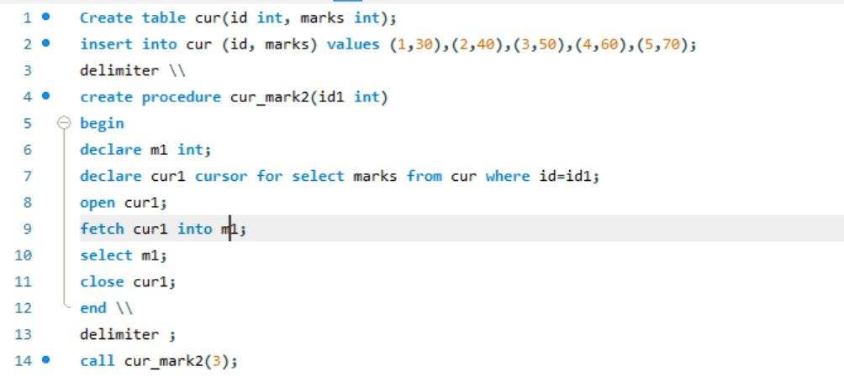

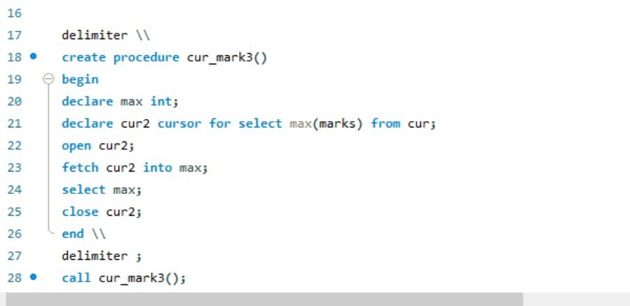

**OUTPUT:**

